**PRACTICAL - 5**

**5.1 AIM: : A cashier at any mall needs to give change of an amount to customers many times in a day. Cashier has multiple number of coins available with different denominations which is described by a set C. Implement the PROGRAM CODE for a cashier to find the minimum number of coins required to find a change of a particular amount A. Output should be the total number of coins required of given denominations.**

**Check the PROGRAM CODE for following test cases:**

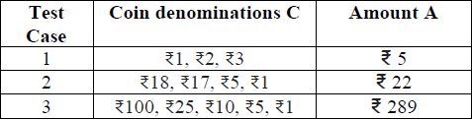

**PROGRAM CODE**:

#include <bits/stdc++.h>

using namespace std;

int minCoins(int coins[], int m, int V)

{

if (V == 0)

return 0;

int res = INT_MAX;

for (int i = 0; i < m; i++)

{

if (coins[i] <= V)

{

int sub_res = minCoins(coins, m, V - coins[i]);

if (sub_res != INT_MAX && sub_res + 1 < res)

res = sub_res + 1;

}

}

return res;

}

int main()

{

int coins[] = {18, 17, 5, 1};

int m = sizeof(coins) / sizeof(coins[0]);

int V = 22;

cout << "Minimum coins required is "

<< minCoins(coins, m, V);

cout << "\n20DCE019-Yatharth Chauhan";

return 0;

}

**OUTPUT**:



**5.2 AIM: Implement the PROGRAM CODE 4.2 using Dynamic Programing. Compare Greedy and Dynamic approach.**

**PROGRAM CODE**:

#include <iostream>

using namespace std;

int maximum(int x, int y)

{

if (x > y)

return x;

else

return y;

}

int knapsack(int bag_capacity, int weight[], int profit[], int number)

{

int matrix[number + 1][bag_capacity + 1];

for (int i = 0; i < number + 1; i++)

for (int j = 0; j < bag_capacity + 1; j++)

{

if (i == 0 || j == 0)

matrix[i][j] = 0;

else if (j >= weight[i - 1])

matrix[i][j] = maximum(matrix[i - 1][j], profit[i - 1] + matrix[i - 1][j - weight[i - 1]]);

else

matrix[i][j] = matrix[i - 1][j];

}

return matrix[number][bag_capacity];

}

int main()

{

int number, bag_capacity;

cout << ".....BINARY KNAPSACK PROBLEM.....";

cout << "\nEnter the size of arrays : ";

cin >> number;

int weight[number], profit[number];

cout << "\nEnter the weights :";

for (int i = 0; i < number; i++)

cin >> weight[i];

cout << "Enter the profits :";

for (int i = 0; i < number; i++)

cin >> profit[i];

cout << "Enter bag capacity : ";

cin >> bag_capacity;

cout << "\nMaximum possible profit is: " << knapsack(bag_capacity, weight, profit, number) << endl;

cout << "\n20DCE019-Yatharth Chauhan";

return 0;

}

**OUTPUT**:

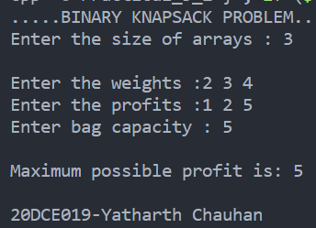

**5.3 AIM: Given a chain < A1, A2,...,An> of n matrices, where for i=1,2,...,n matrix Ai with dimensions. Implement the PROGRAM CODE to fully parenthesize the product A1,A2,...,An in a way that minimizes the number of scalar multiplications. Also calculate the number of scalar multiplications for all possible combinations of matrices.**

|  |  |  |
| --- | --- | --- |
| **Test Case** | **n** | **Matrices with dimensions** |
| 1 | 3 | A1:3*5,A2:5*6,A3:6*4 |
| 2 | 6 | A1: 30*35, A2: 35*15, A3: 15*5, A4: 5*10, A5: 10*20, A6: 20*25 |

**PROGRAM CODE**:

#include <bits/stdc++.h>

using namespace std;

int MatrixMultiplication(int p[], int n)

{

int m[n][n];

int i, j, k, L, q;

for (i = 1; i < n; i++)

m[i][i] = 0;

// L is chain length.

for (L = 2; L < n; L++)

{

for (i = 1; i < n - L + 1; i++)

{

j = i + L - 1;

m[i][j] = INT_MAX;

for (k = i; k <= j - 1; k++)

{

// q = cost/scalar multiplications

q = m[i][k] + m[k + 1][j] +

p[i - 1] * p[k] * p[j];

if (q < m[i][j])

m[i][j] = q;

}

}

}

return m[1][n - 1];

}

int main()

{

int n;

cout << " ...::::MATRIX MULTIPLICATION:::::...\n\n";

cout << "ENTER THE TOTAL NUMBER OF DIMENSION VALUES : ";

cin >> n;

int arr[n];

for (int i = 0; i < n; i++)

{

cout << "Enter P" << i << " : ";

cin >> arr[i];

}

int length = sizeof(arr) / sizeof(arr[0]);

cout << "MINIMUM NUMBER OF MULITIPLICATION IS : " << MatrixMultiplication(arr, length) << endl;

cout << "\n20DCE019-Yatharth Chauhan";

return 0;

}

**OUTPUT**:

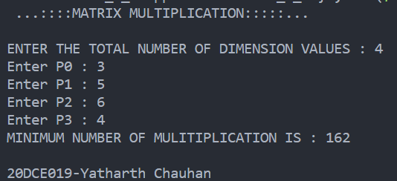

**5.4 AIM: Program to implement all pairs shortest path.**

**PROGRAM CODE**:

#include <iostream>

#include <climits>

#include <iomanip>

using namespace std;

#define N 4

#define M INT_MAX

void printPath(int path[][N], int v, int u)

{

if (path[v][u] == v)

return;

printPath(path, v, path[v][u]);

cout << path[v][u] << " ";

}

void printSolution(int cost[N][N], int path[N][N])

{

for (int v = 0; v < N; v++)

{

for (int u = 0; u < N; u++)

{

if (u != v && path[v][u] != -1)

{

cout << "Shortest Path from " << v << " -> " << u << " is ("

<< v << " ";

printPath(path, v, u);

cout << u << ")" << endl;

}

}

}

}

void floydWarshall(int adjMatrix[][N])

{

int cost[N][N], path[N][N];

for (int v = 0; v < N; v++)

{

for (int u = 0; u < N; u++)

{

cost[v][u] = adjMatrix[v][u];

if (v == u)

path[v][u] = 0;

else if (cost[v][u] != INT_MAX)

path[v][u] = v;

else

path[v][u] = -1;

}

}

for (int k = 0; k < N; k++)

{

for (int v = 0; v < N; v++)

{

for (int u = 0; u < N; u++)

{

if (cost[v][k] != INT_MAX && cost[k][u] != INT_MAX && cost[v][k] + cost[k][u] < cost[v][u])

{

cost[v][u] = cost[v][k] + cost[k][u];

path[v][u] = path[k][u];

}

}

if (cost[v][v] < 0)

{

cout << "Negative Weight Cycle Found!!";

return;

}

}

}

printSolution(cost, path);

}

int main()

{

int adjMatrix[N][N] =

{

{0, M, -2, M},

{4, 0, 3, M},

{M, M, 0, 2},

{M, -1, M, 0}};

floydWarshall(adjMatrix);

cout << "\n20DCE019-Yatharth Chauhan";

return 0;

}

**OUTPUT**:

